Liveness probe and health check

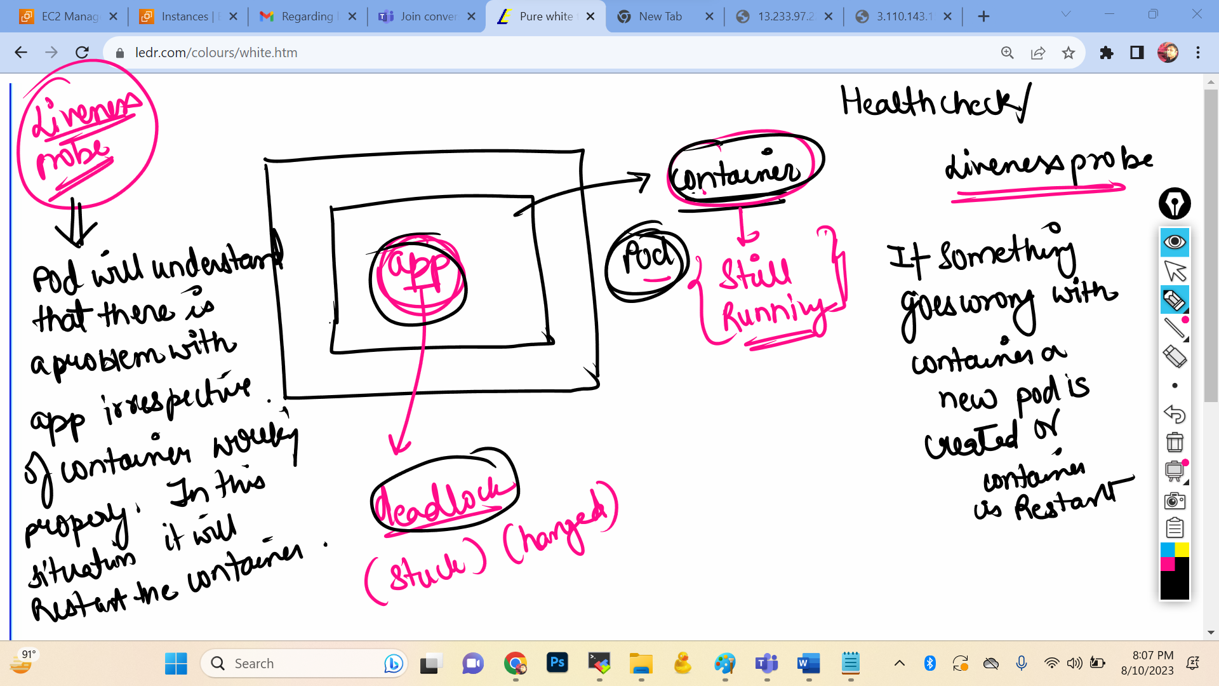



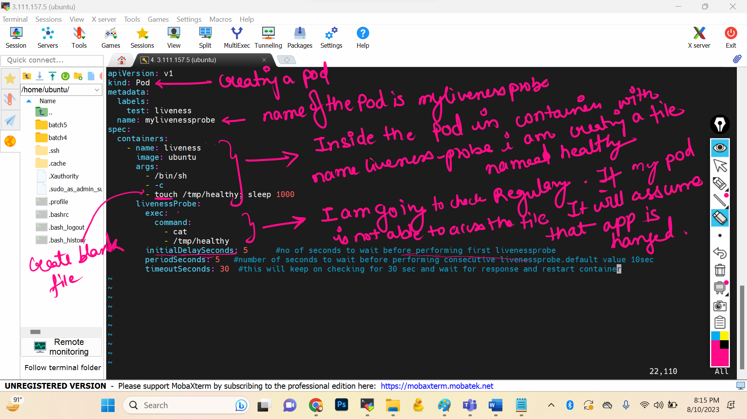

Press i to insert

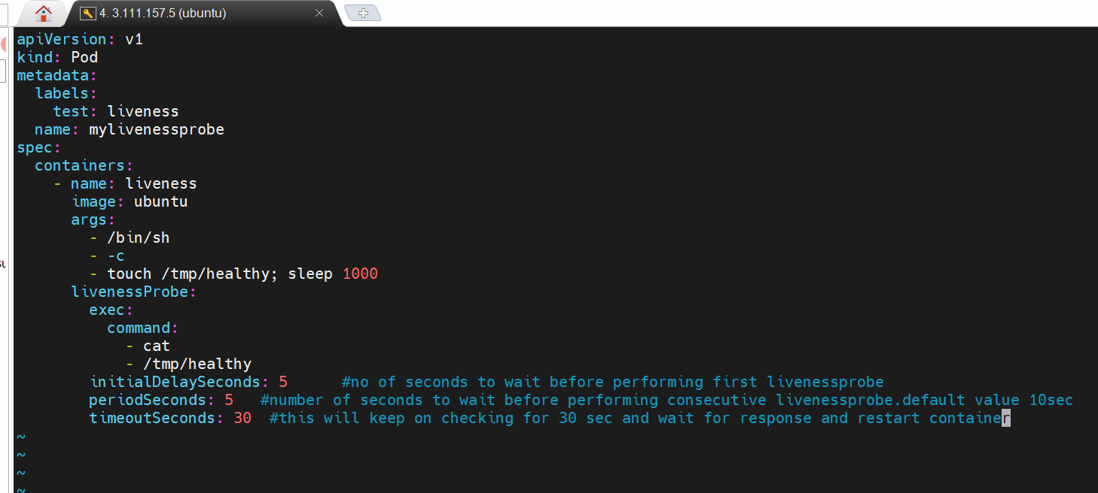

apiVersion: v1

kind: Pod

metadata:

labels:

test: liveness

name: mylivenessprobe

spec:

containers:

- name: liveness

image: ubuntu

args:

- /bin/sh

- -c

- touch /tmp/healthy; sleep 1000

livenessProbe:

exec:

command:

- cat

- /tmp/healthy

initialDelaySeconds: 5 #no of seconds to wait before performing first livenessprobe

periodSeconds: 5 #number of seconds to wait before performing consecutive livenessprobe.default value 10sec

timeoutSeconds: 30 #this will keep on checking for 30 sec and wait for response and restart container

Press esc :wq



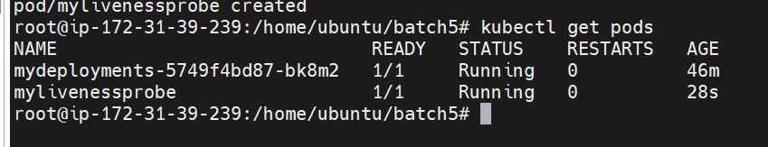

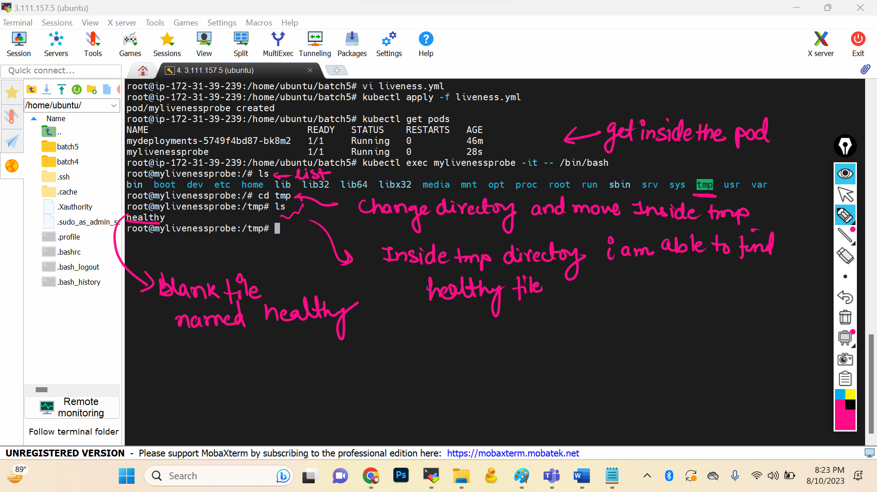

If I delete this blank file



Commands used inside container:

1 ls

2 cd tmp

3 ls

4 rm -rf healthy

5 ls

6 history

Wait for some time..30-40 sec …you will see automatically u will come out of the machine

